Personal Auto Final Assessment

Contents
Demo National Missouri Personal Auto 1
Policy Coverages 2
Bodily Injury 2
Property Damage 2
Medical Payments 3
Uninsured Motorists 3
Underinsured Motorists 3
Additional Coverages 5
Other Than Collision (OTC) 5
Collision (COLL) 5
Driver & Vehicle Information 6
Driver Assignment 6
Maximum Number of Vehicles 6
Maximum Number of Drivers 6
Rating Algorithms 7
Policy Premium 7
Vehicle Premium 7
Bodily Injury Premium 7
CSL Property Damage Add On 7
Property Damage Premium 7
Medical Payments Premium 7
Uninsured Motorist Premium 8
Underinsured Motorist Premium 8
Other Than Collision Premium 8
OTC Base Rate 8
Collision Premium 8
Collision Base Rate 8
Rate Tables 10
Base Premiums 10
BI Limit Factors 11
Term Factor 11
Property Damage Limit Factors 12
Medical Payments Limit Factors 12
Symbol Factors 1990 or Later 13
Symbol Factors 1989 or Prior 14
Vehicle Age Factors 15
OTC Deductible Factors 15
Collision Deductible Factors 15
Uninsured Motorist Base Premiums 16
Underinsured Motorist Base Premiums 17
Territory Table 17

Personal Auto

Policy Coverages
Bodily Injury

Limits
Available split limits for bodily injury coverage are as follows:
$25,000/$50,000
$50,000/$100,000
$100,000/$200,000
$100,000/$300,000
$300,000/$300,000
$250,000/$500,000
In addition, the following combined single limits (CSL) are offered:
$ 60,000 CSL
$ 75,000 CSL
$100,000 CSL
$200,000 CSL
$300,000 CSL
$500,000 CSL

Property Damage

Limits
If property damage is a selected coverage, the following limits are available:
$ 10,000 $100,000
$ 15,000 $150,000
$ 20,000 $200,000
$ 25,000 $250,000
$ 50,000

Rules
- Property Damage Coverage is included with Bodily Injury CSL.
- Bodily Injury must be selected in order to get Property Damage Coverage.

Medical Payments

Limits
The following limits are available for Medical Payments Coverage:
$1,000 $ 5,000
$2,000 $10,000

Uninsured Motorists

Limits
The following split limits are available for Uninsured Motorist Coverage:
$25,000/$50,000
$50,000/$100,000
$100,000/$200,000
$100,000/$300,000
$300,000/$300,000
$250,000/$500,000
In addition, the following combined single limits (CSL) are offered:
$ 60,000 CSL
$ 75,000 CSL
$100,000 CSL
$200,000 CSL
$300,000 CSL
$500,000 CSL

Rules
The Uninsured Motorist limit may not exceed the limit for bodily injury coverage.

Underinsured Motorists

Limits
The following split limits are available for Underinsured Motorist Coverage:
$25,000/$50,000
$50,000/$100,000
$100,000/$200,000
$100,000/$300,000
$300,000/$300,000
$250,000/$500,000
In addition, the following combined single limits (CSL) are offered:
$ 60,000 CSL
$ 75,000 CSL
$100,000 CSL
$200,000 CSL
$300,000 CSL
$500,000 CSL

Rules
The Underinsured Motorist limit may not exceed the limit for bodily injury coverage.

Additional Coverages
Other Than Collision (OTC)

Deductibles
The following deductibles are available for OTC Coverage:
No Coverage
$0
$50
$100
$200
$250
$500
$1,000

Collision (COLL)

Deductibles
The following deductibles are available for COLL Coverage:
No Coverage
$100
$200
$250
$500
$1,000
$1,500

Rules
Collision Coverage is not available for a Liability Only coverage option.

Driver & Vehicle Information
Driver Assignment
Drivers are manually assigned to vehicle for rating purposes.

Maximum Number of Vehicles
The maximum number of vehicles that may be written on a policy is 2.

Maximum Number of Drivers
The maximum number of drivers that can be covered on a policy is 1.

Rating Algorithms
Policy Premium
= | Sum of All Vehicle Premiums

Vehicle Premium
= | Bodily Injury Premium
+ | Property Damage Premium
+ | Medical Payments Premium
+ | Uninsured Motorists Premium
+ | Underinsured Motorists Premium
+ | OTC Premium
+ | Collision Premium

Bodily Injury Premium
= | (BI Base Premium
* | BI Increased Limit Factor) | Dollar Round
+ | CSL Property Damage Add On
+ | Inexperienced Operator Surcharge
* | Term Factor | Dollar Round
CSL Property Damage Add On
= | PD Base Premium
* | BI Increased Limit Factor | Dollar Round

Property Damage Premium
= | PD Base Premium
* | Increased Limit Factor | Dollar Round
+ | Inexperienced Operator Surcharge
* | Term Factor | Dollar Round

Medical Payments Premium
= | MP Base Premium
* | Increased Limit Factor | Dollar Round
+ | Inexperienced Operator Surcharge
* | Term Factor | Dollar Round

Uninsured Motorist Premium
= | UM Base Premium
* | Term Factor | Dollar Round

Underinsured Motorist Premium
= | UIM Base Premium
* | Term Factor | Dollar Round
Other Than Collision Premium
= | OTC Base Rate
+ | Inexperienced Operator Surcharge
 | Term Factor | Dollar Round

OTC Base Rate
= | OTC Base Premium
* | Symbol Factor | Dollar Round
* | Age Factor | Dollar Round
* | Deductible Factor | Dollar Round

Collision Premium
= | Collision Base Rate
+ | Inexperienced Operator Surcharge
* | Term Factor | Dollar Round

Collision Base Rate
= | Collision Base Premium
* | Symbol Factor | Dollar Round
* | Age Factor | Dollar Round
* | Deductible Factor | Dollar Round

Rate Tables
Base Premiums
Territory | BI | PD | Med Pay | OTC | COLL
2 | 242 | 47 | 15 | 78 | 174
3 | 107 | 22 | 15 | 69 | 116
4 | 138 | 28 | 18 | 89 | 148
5 | 103 | 22 | 15 | 69 | 100
6 | 122 | 24 | 15 | 72 | 105
8 | 141 | 28 | 18 | 89 | 174
9 | 103 | 22 | 15 | 69 | 109
10 | 103 | 22 | 15 | 69 | 109
12 | 293 | 60 | 18 | 89 | 243
13 | 204 | 41 | 18 | 89 | 174
16 | 145 | 28 | 15 | 78 | 143
17 | 138 | 28 | 15 | 72 | 105
25 | 145 | 28 | 15 | 78 | 129
26 | 135 | 27 | 15 | 78 | 126
27 | 109 | 22 | 15 | 72 | 132
28 | 103 | 22 | 15 | 72 | 114
29 | 107 | 22 | 15 | 72 | 122
30 | 204 | 41 | 18 | 89 | 174
31 | 211 | 43 | 18 | 89 | 148
32 | 211 | 43 | 18 | 89 | 148
33 | 197 | 41 | 17 | 89 | 142
34 | 197 | 41 | 17 | 89 | 142
35 | 197 | 41 | 17 | 89 | 142
36 | 141 | 28 | 15 | 78 | 129
37 | 109 | 22 | 15 | 69 | 126
38 | 107 | 22 | 15 | 69 | 116

BI Limit Factors
Limit | Factor
25000/50000 | 1.00
50000/100000 | 1.24
100000/200000 | 1.44
100000/300000 | 1.45
300000/300000 | 1.64
250000/500000 | 1.63
60000CSL | 1.13
75000CSL | 1.14
100000CSL | 1.27
200000CSL | 1.32
300000CSL | 1.43
500000CSL | 1.54

Term Factor
Policy Term | Factor
6 Months | 0.5
12 Months | 1.0

Property Damage Limit Factors
Limit | Factor
No Coverage | 0.00
$10,000 | 1.00
$15,000 | 1.02
$20,000 | 1.03
$25,000 | 1.04
$50,000 | 1.07
$100,000 | 1.11
$150,000 | 1.14
$200,000 | 1.16
$250,000 | 1.18

Medical Payments Limit Factors
Limit | Factor
No Coverage | 0.00
$1,000 | 1.00
$2,000 | 1.20
$5,000 | 1.49
$10,000 | 2.20

Symbol Factors 1990 or Later
Symbol | OTC | COLL
1 | 0.55 | 0.68
2 | 0.71 | 0.80
3 | 0.80 | 0.92
4 | 0.80 | 0.92
5 | 1.00 | 1.00
6 | 1.00 | 1.00
7 | 1.22 | 1.12
8 | 1.22 | 1.12
10 | 1.45 | 1.24
11 | 1.45 | 1.24
12 | 1.67 | 1.32
13 | 1.67 | 1.32
14 | 2.14 | 1.65
15 | 2.14 | 1.65
16 | 3.02 | 1.78
17 | 3.02 | 1.78
18 | 3.51 | 1.91
19 | 3.51 | 1.91
20 | 4.08 | 2.04
21 | 4.08 | 2.04
22 | 4.73 | 2.16
23 | 4.73 | 2.16
24 | 5.51 | 2.29
25 | 6.41 | 2.42
26 | 8.61 | 2.69
27 | 8.61 | 2.69

Symbol Factors 1989 or Prior
Symbol | OTC | COLL
1 | 0.29 | 0.50
2 | 0.29 | 0.50
3 | 0.29 | 0.50
4 | 0.33 | 0.53
5 | 0.41 | 0.58
6 | 0.55 | 0.68
7 | 0.71 | 0.80
8 | 0.80 | 0.92
10 | 1.00 | 1.00
11 | 1.22 | 1.12
12 | 1.45 | 1.24
13 | 1.67 | 1.32
14 | 2.14 | 1.65
15 | 3.02 | 1.78
16 | 3.51 | 1.91
17 | 4.08 | 2.04
18 | 4.73 | 2.16
19 | 5.51 | 2.29
20 | 6.41 | 2.42
21 | 8.61 | 2.69

Vehicle Age Factors
Vehicle Age | Factor
1 or Less | 1.00
2 | 0.95
3 | 0.91
4 | 0.88
5 | 0.86
6 or More | 0.85

Inexperienced Operator Surcharge
Years Licensed | Surcharge Factor
<2 | 0.25
2 or More | 0.00
OTC Deductible Factors
Deductible | Factor
No Coverage | 0.00
0 | 2.50
$50 | 1.50
$100 | 1.00
$200 | 0.75
$250 | 0.70
$500 | 0.60
$1,000 | 0.55

Collision Deductible Factors
Deductible | Factor
No Coverage | 0.00
$100 | 1.64
$200 | 1.00
$250 | 0.95
$500 | 0.82
$1,000 | 0.60
Uninsured Motorist Base Premiums
Limit | Premium
No Coverage | 0
25000/50000 | 13
50000/100000 | 15
100000/200000 | 16
100000/300000 | 18
300000/300000 | 20
250000/500000 | 22
60000CSL | 13
75000CSL | 15
100000CSL | 17
200000CSL | 18
300000CSL | 20
500000CSL | 23

Underinsured Motorist Base Premiums
Limit | Premium
No Coverage | 0
25000/50000 | 13
50000/100000 | 15
100000/200000 | 16
100000/300000 | 18
300000/300000 | 20
250000/500000 | 22
60000CSL | 13
75000CSL | 15
100000CSL | 17
200000CSL | 18
300000CSL | 20
500000CSL | 23

Territory Table
This table is also available as an Excel spreadsheet (Territory.xls).
County | Territory | County | Territory | County | Territory | County | Territory
Adair | 29 | Dallas | 27 | Livingston | 28 | Randolph | 28
Andrew | 28 | Davies | 28 | McDonald | 27 | Ray | 28
Atchison | 28 | DeKalb | 28 | Macon | 29 | Reynolds | 27
Audrain | 29 | Dent | 29 | Madison | 27 | Ripley | 27
Barry | 27 | Douglas | 27 | Maries | 29 | Saint Charles | 4
Barton | 27 | Dunklin | 17 | Marion | 29 | Saint Clair | 27
Bates | 27 | Franklin | 29 | Mercer | 29 | Saint Francois | 27
Benton | 29 | Gasconade | 29 | Miller | 29 | Saint Louis | 27
Bollinger | 27 | Gentry | 28 | Mississippi | 17 | Saint Louis City | 33
Boone | 29 | Greene | 6 | Montineau | 29 | Sainte Genevieve | 33
Buchanan | 28 | Grundy | 28 | Monroe | 29 | Saline | 28
Butler | 17 | Harrison | 28 | Montgomery | 29 | Schuyler | 29
Caldwell | 28 | Henry | 28 | Morgan | 29 | Scotland | 29
Callaway | 29 | Hickory | 27 | New Madrid | 17 | Scott | 17
Camden | 29 | Holt | 28 | Newton | 27 | Shannon | 27
Cape Girardeau | 27 | Howard | 29 | Nodaway | 28 | Shelby | 29
Carroll | 28 | Howell | 27 | Oregon | 27 | Stoddard | 17
Carter | 27 | Iron | 27 | Osage | 29 | Stone | 27
Cass | 28 | Jackson | 2 | Ozark | 27 | Sullivan | 29
Cedar | 27 | Jasper | 37 | Pemiscot | 17 | Taney | 27
Chariton | 29 | Jefferson | 8 | Perry | 27 | Texas | 27
Christian | 27 | Johnson | 28 | Pettis | 29 | Vernon | 27
Clark | 29 | Knox | 29 | Phelps | 29 | Warren | 29
Clay | 2 | Laclede | 27 | Pike | 29 | Washington | 27
Clinton | 10 | Lafayette | 28 | Platte | 9 | Wayne | 27
Cole | 38 | Lawrence | 27 | Polk | 27 | Webster | 27
Cooper | 29 | Lewis | 29 | Pulaski | 27 | Worth | 28
Crawford | 29 | Lincoln | 29 | Putnam | 29 | Wright | 27
Dade | 27 | Linn | 29 | Ralls | 29

Test Cases
Test Case 1

Applicant Information
Name: | John Smith
Address 1: | 111 Main St.
City (Read Only) | Allenton
County (Read Only) | Saint Louis
State: | MO
Zip Code: | 63001
Primary Phone: | 417-555-3333
Term | 6 Months

Driver Information
First Name | Mike
Date Of Birth (mm-dd-yyyy) | 06-04-1964
Age (Read Only) | 53
License Date | 04-04-1984
Gender | Male
Marital Status | Married
Driver Training | N/A

Driver Detail Pop-Up
First Name | Mike
Middle Initial | Mr
Last Name | David
Date Of Birth | 04-06-1964
License Date | 04-04-1984
Gender | Male
Marital Status | Married
Occupation | Working
Relation To Applicant | Spouse
Driver Training | N/A

Vehicle Information
Vehicle # (Read Only) | 1
Model Year | 2000
Make | ACURA
Model | 3.2TL
Description | SED, 4Dr, 6Cyl, 3.2L, VTEC, SOHC, AUTO, Airbag(F/S) [14, 18]
Garaging Zip | 63001

Coverage Information
Bodily Injury | $250,000/$500,000
Property Damage | $20,000
Med Pay | $2,000
Uninsured Motorist | $100,000/$200,000
Underinsured Motorist | $25,000/$50,000
Vehicle (Read Only) | 2000 ACURA 3.2TL
Symbol (Read Only) | 14
County (Read Only) | Saint Louis
OTC Deductible | $200
Collision Deductible | $500

Rate
Total Result | $350
Test Case 2

Applicant Information
Name: | Mark Farris
Address 1: | 222 Main St.
City (Read Only) | Bolivar
County (Read Only) | Polk
State: | CO
Zip Code: | 65613
Primary Phone: | 417-555-4444
Term | 1 Year

Driver Information
First Name | Dennis
Date Of Birth | 04-05-2004
Age (Read Only) | 13
License Date | 04-09-2014
Gender | Female
Marital Status | Single
Driver Training | Check box checked

Driver Detail Pop-Up
First Name | Dennis
Middle Initial | Mrs
Last Name | Lee
Date Of Birth | 04-05-2004
License Date | 04-09-2014
Gender | Female
Marital Status | Single
Occupation | Working
Relation To Applicant | Named Insured
Driver Training | Check box checked

Vehicle Information

First Vehicle
Vehicle # (Read Only) | 1
Model Year | 2005
Make | BUICK
Model | LACROSSE CX
Description | SED, 6Cyl, 3.8L, 4Dr, ActiveBelts, Airbag(F) [12, 15]
Garaging Zip | 65613

Second Vehicle
Vehicle # (Read Only) | 2
Model Year | 2004
Make | AUDI
Model | A4 1.8T
Description | CONV, 4Cyl, 1.8L, Airbag(F/S), 2Dr, DOHC, ActiveBelts, Turbo [22, 20]
Garaging Zip | 63005

Coverage Information
Bodily Injury | $75,000 CSL
Property Damage | Included
Med Pay | $1,000
Uninsured Motorist | $60,000 CSL
Underinsured Motorist | No Coverage
First Vehicle
Vehicle (Read Only) | 2005 BUICK LACRO
Symbol (Read Only) | 12
County (Read Only) | Polk
OTC Deductible | $100
Collision Deductible | $1,000
Second Vehicle
Vehicle (Read Only) | 2004 AUDI A4 1.
Symbol (Read Only) | 22
County (Read Only) | Saint Louis
OTC Deductible | $50
Collision Deductible | No Coverage

Rate
Total Result | $1,207
Test Case 3

Applicant Information
Name: | Mark Taylor
Address 1: | 333 Main St.
City (Read Only) | Fenton
County (Read Only) | Saint Louis
State: | CT
Zip Code: | 63026
Primary Phone: | 417-555-8888
Term | 1 Year

Driver Information
First Name | Jack
Date Of Birth | 04-08-1987
Age (Read Only) | 30
License Date | 04-05-1994
Gender | Male
Marital Status | Married
Driver Training | N/A

Driver Detail Pop-Up
First Name | Jack
Middle Initial | Mr
Last Name | Wilson
Date Of Birth | 04-08-1987
License Date | 04-05-1994
Gender | Male
Marital Status | Married
Occupation | Working
Relation To Applicant | Parent
Driver Training | N/A

Vehicle Information

First Vehicle
Vehicle # (Read Only) | 1
Model Year | 2004
Make | BMW
Model | 325I
Description | SED, 6Cyl, 2.5L, 4Dr, DOHC, MAN, ActiveBelts, Airbag(F/S) [16, 18]
Garaging Zip | 63039

Second Vehicle
Vehicle # (Read Only) | 2
Model Year | 2002
Make | BUICK
Model | PARK AVENUE
Description | SED, 6Cyl, 3.8L, 4Dr, ActiveBelts, Airbag(F/S) [12, 20]
Garaging Zip | 63070

Coverage Information
Bodily Injury | $300,000 CSL
Property Damage | Included
Med Pay | $5,000
Uninsured Motorist | $75,000 CSL
Underinsured Motorist | $200,000 CSL
First Vehicle
Vehicle (Read Only) | 2004 BMW 325I
Symbol (Read Only) | 16
County (Read Only) | Franklin
OTC Deductible | No Coverage
Collision Deductible | $100
Second Vehicle
Vehicle (Read Only) | 2002 BUICK PARK
Symbol (Read Only) | 12
County (Read Only) | Jefferson
OTC Deductible | $100
Collision Deductible | $500

Rate
Total Result | $1,141

Test Case Results
Test Case 1
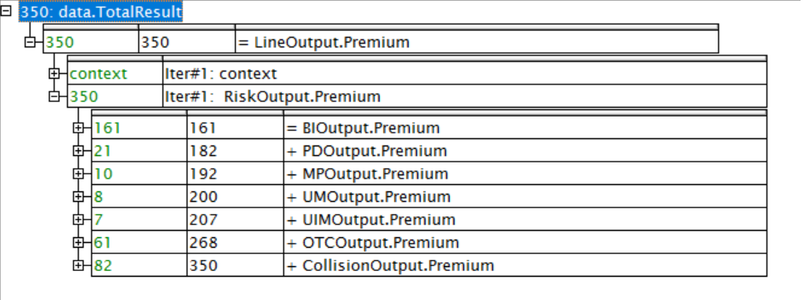
Test Case 2
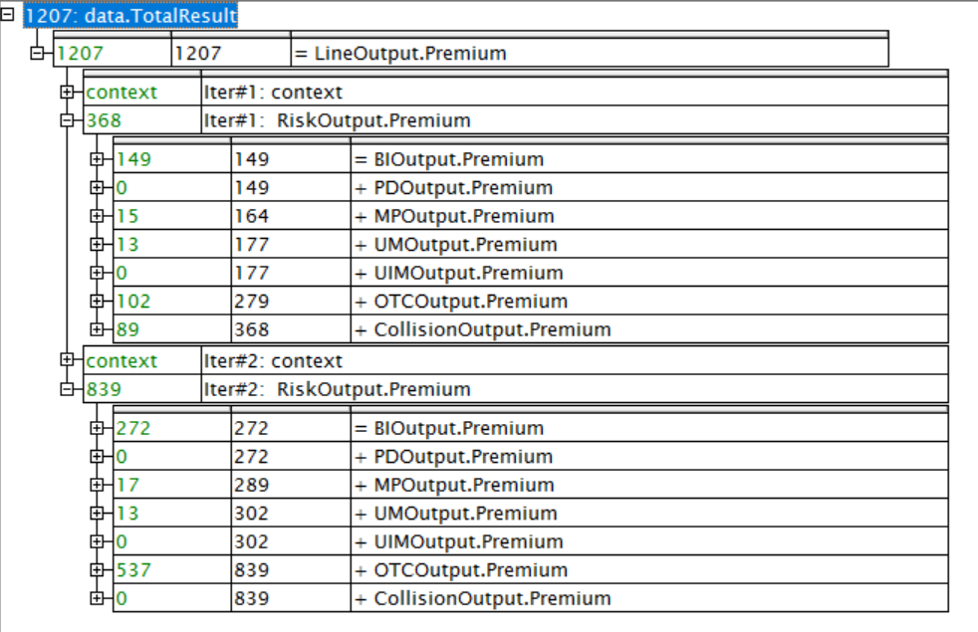
Test Case 3
